**Forecast Solution**

**Coca-Cola Sales Forecast solution**

* I have created 4 dummy variables because the data is a quarterly data. Following is the plot for the sales data, looks like there is a upward trend with multiplicative seasonality:

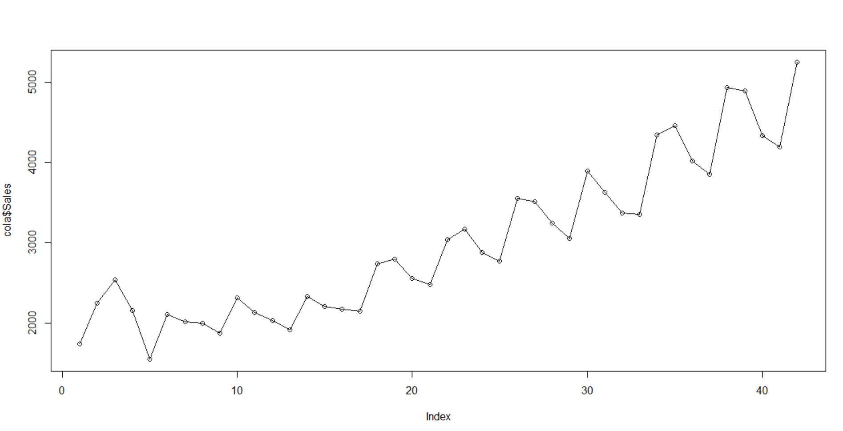

* While creating the ARIMA model, I considered as integrated model because the sales data is a volatile data, so it is better to consider moving average. So the d value is 1.
* For q achieved the value from below graph, lag value before 1st insignificant lag, here it’s 8:

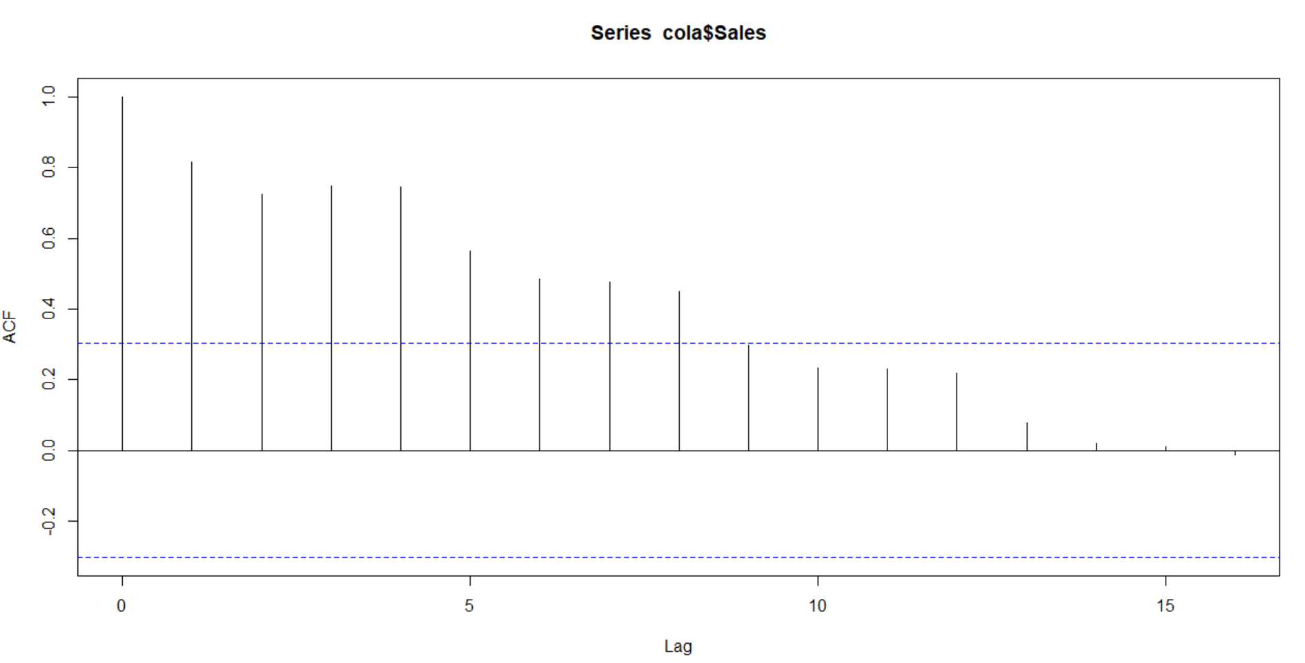

* For p achieved the value from below graph, 1st significant lag, here it’s 1:

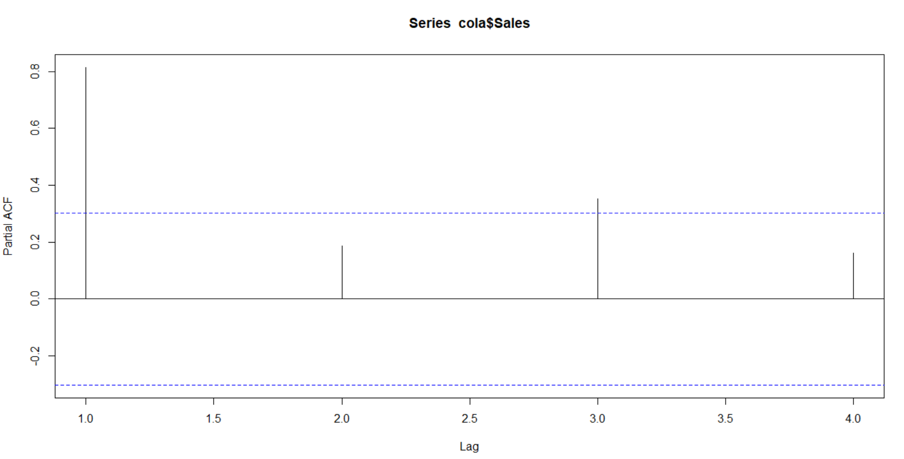

* Forecast graph for ARIMA:

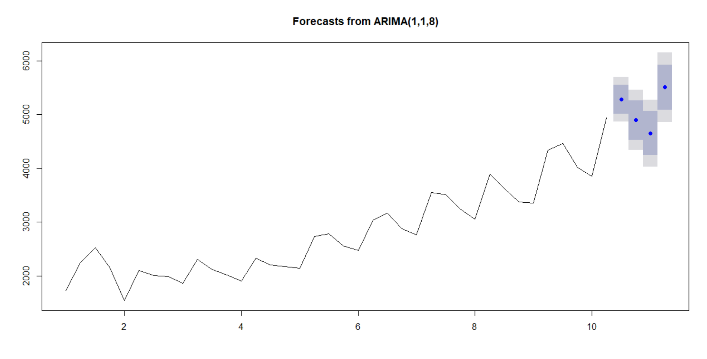

* Forecast graph for Simple Moving Average:

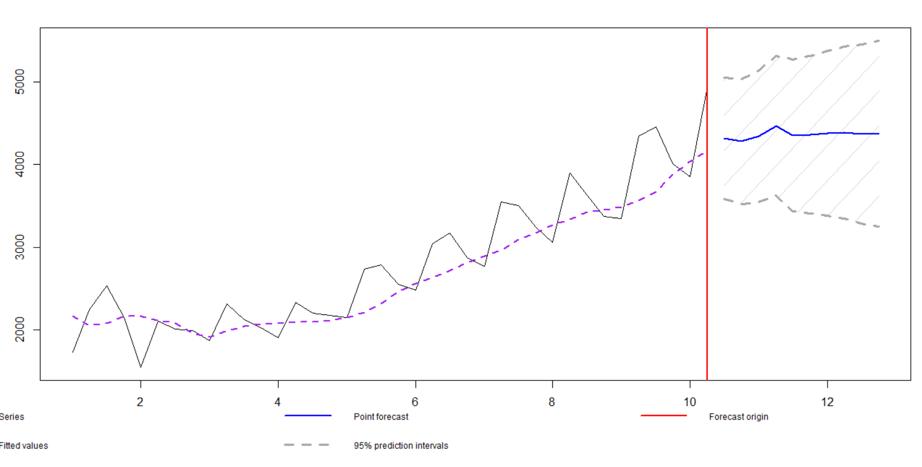

* Forecast graph for HoltWinter’s:

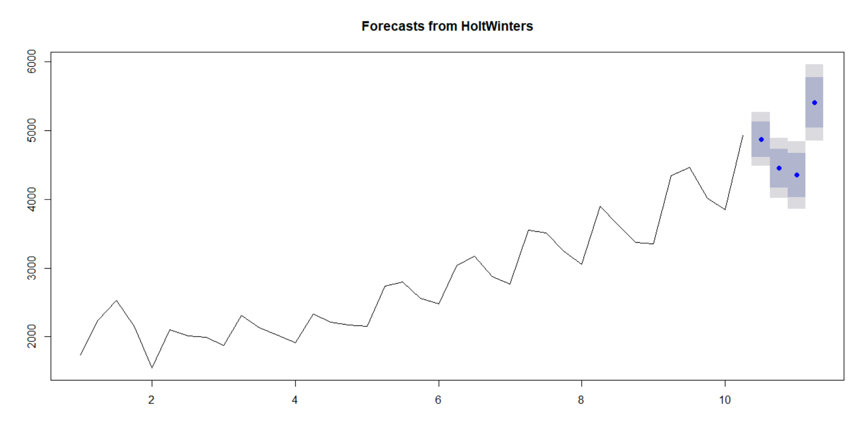

* I performed various models and following is the RMSE comparison table:

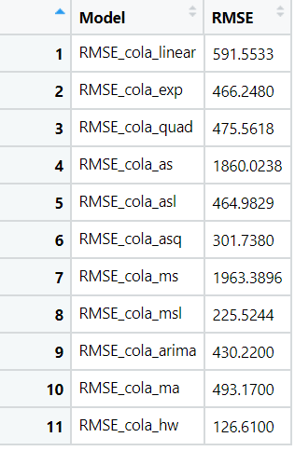

* The lowest RMSE was achieved by the Holt Winter’s model = 126.61. So we can finalize the Holt Winter’s model.

**Airline Passenger Forecast solution**

* I have created 12 dummy variables because the data is a monthly data. Following is the plot for the passenger data, looks like there is a upward trend with multiplicative seasonality:

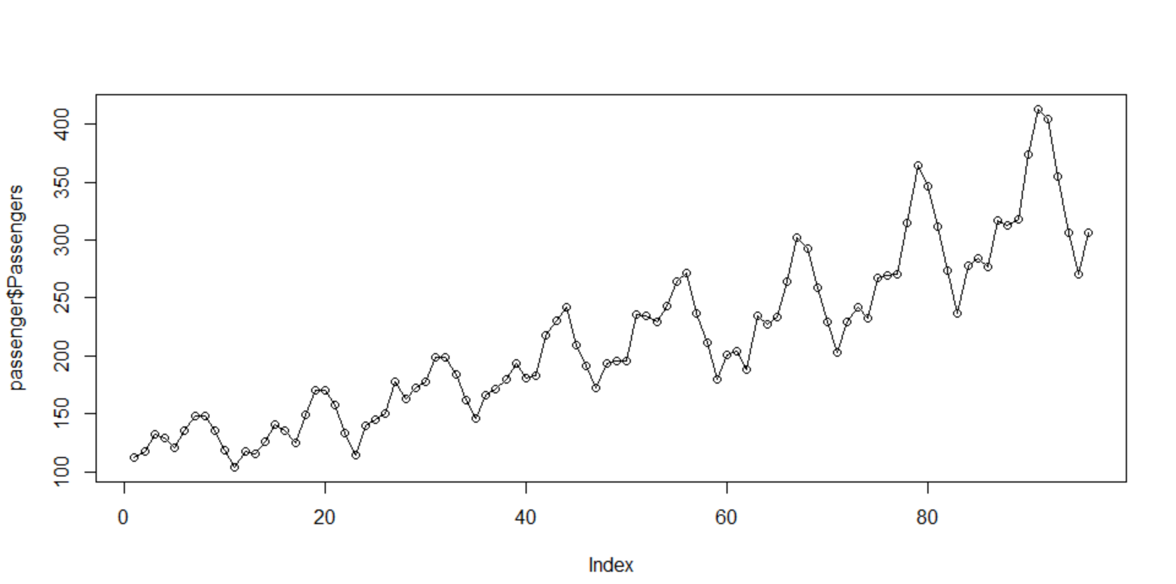

* While creating the ARIMA model, I considered as stationary model because the passenger data is not so volatile data. So the d value is 0.
* For q achieved the value from below graph, lag value before 1st insignificant lag, here it’s 25:

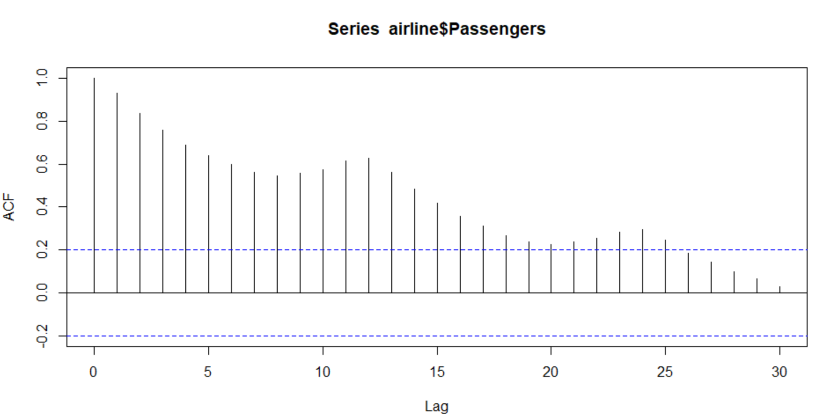

* For p achieved the value from below graph, 1st significant lag, here it’s 1: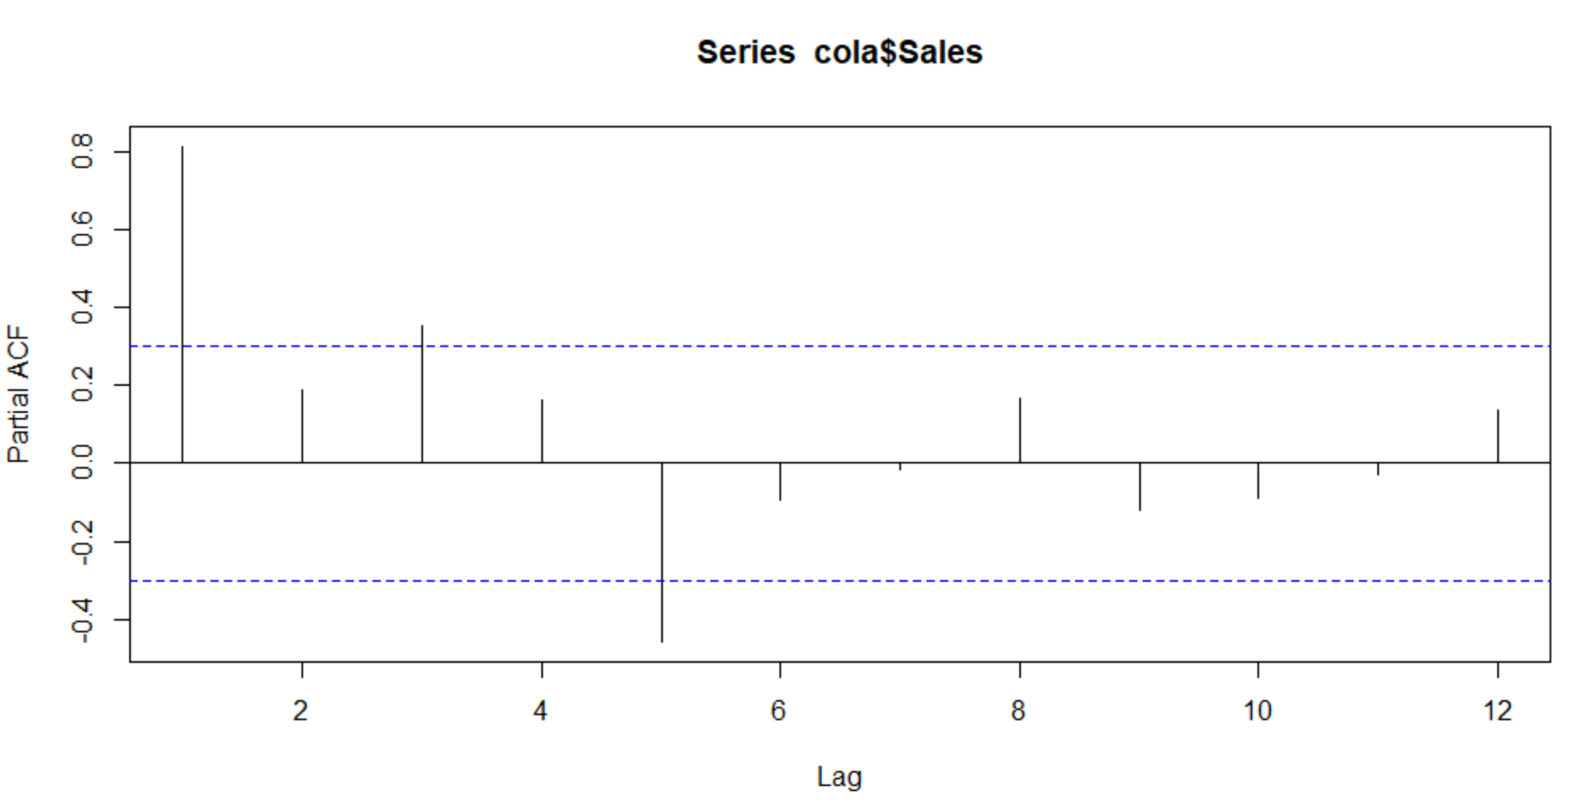
* Forecast graph for ARIMA:

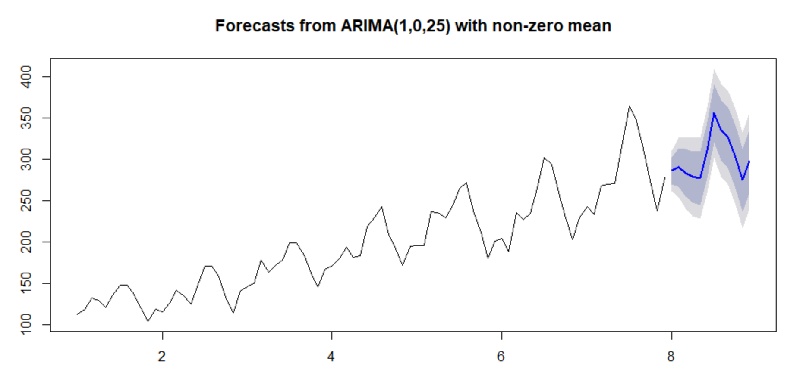

* Forecast graph for Simple Moving Average:

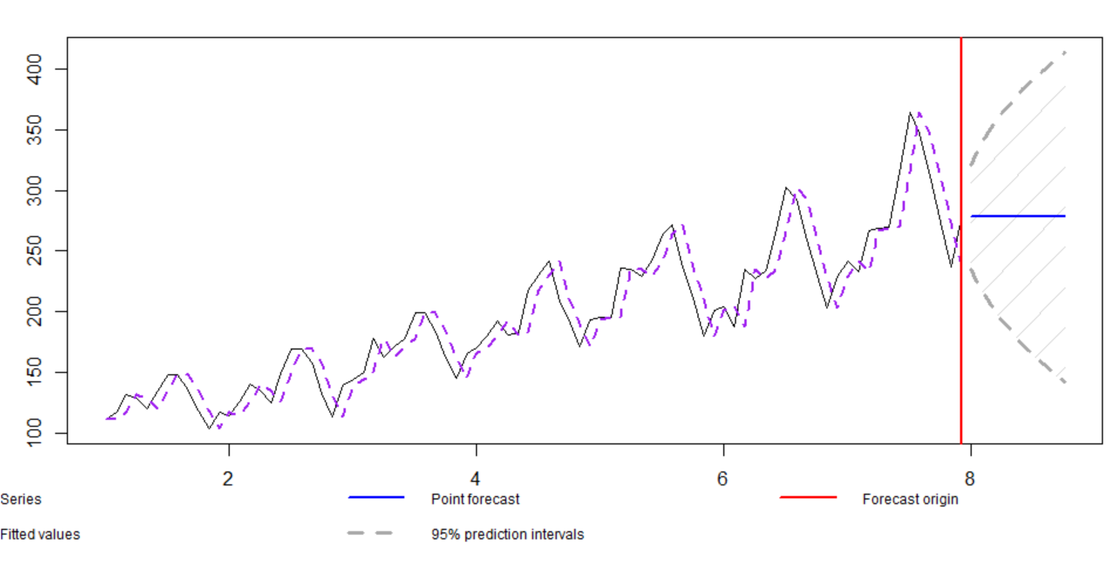

* Forecast graph for HoltWinter’s:

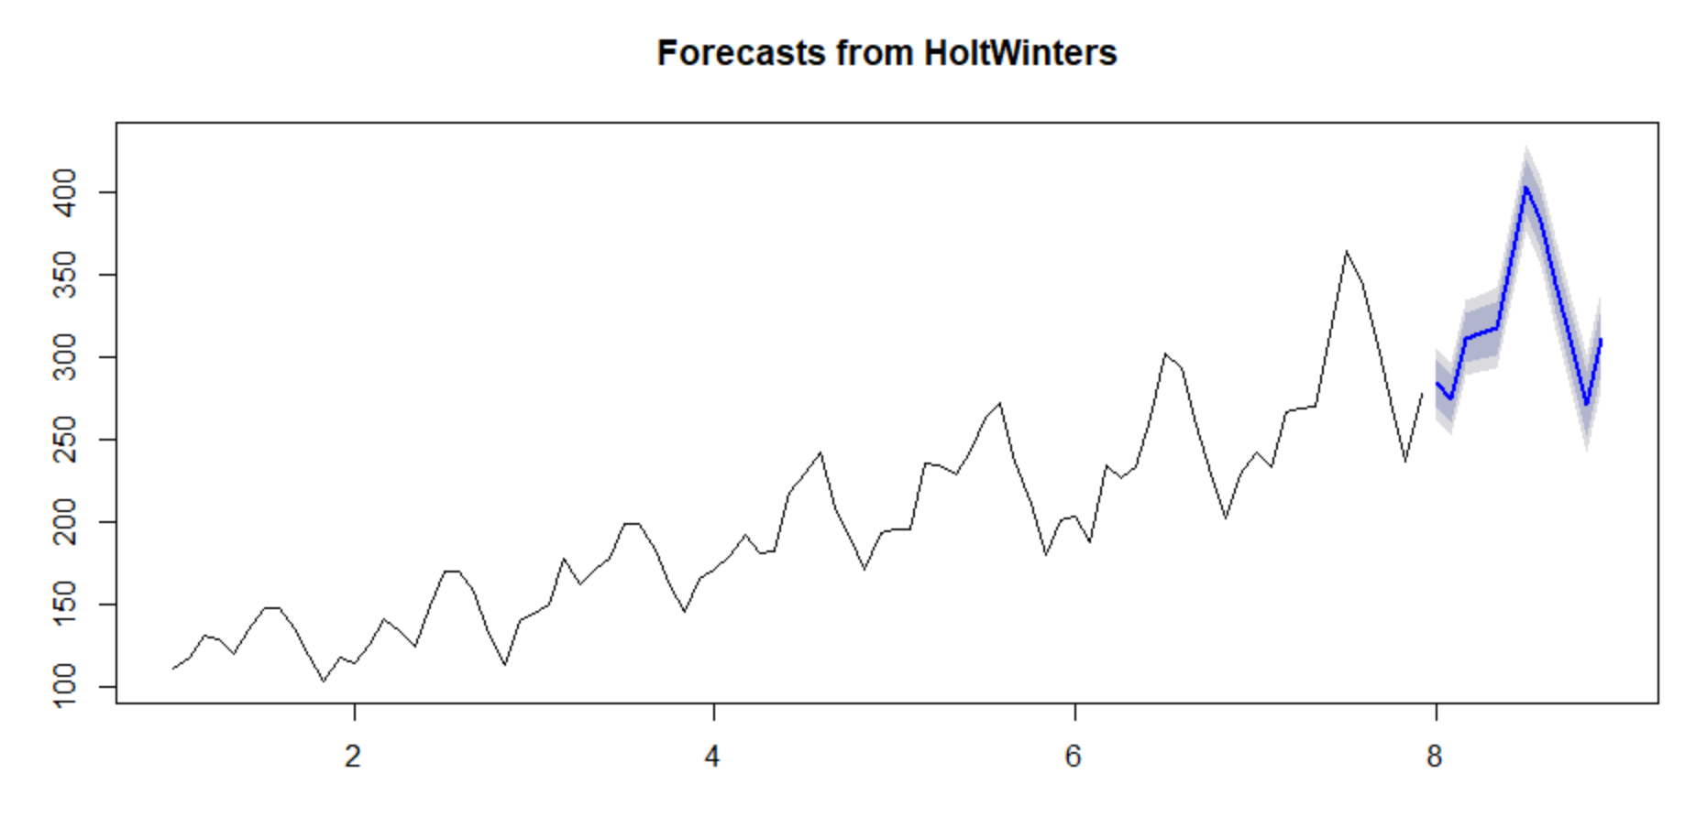

* I performed various models and following is the RMSE comparison table:

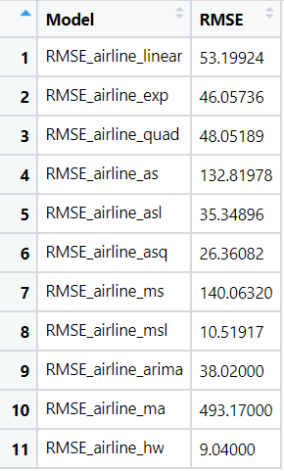

* The lowest RMSE was achieved by the Holt Winter’s model = 9.04. So we can finalize the Holt Winter’s model.